Project 2
<Othello Game>

Name: Jonathan D. Tarris
Course: CSC-5
Class#: 40375
Date: 02/10/14

Introduction
Title: Othello

Othello is a fairly simple game to learn involving simple rule yet complex strategy. The object of the game is to have the majority of your color disks face up on the board at the end of the game. This can be accomplished by placing your tiles on the board and flipping your opponent's tiles by surrounding or “outflanking” them.

How To Play

The game is conventionally played on a 8x8 board. Before play begins each player is given 32 multi-sided disks, with white on one side and black on the other. The Game board has a predetermined setup with 2 white side tiles and 2 black side tiles placed across from each other in the center of the board.

Players then begin taking turns placing tiles on the board starting with black. In order to make a valid move you must flip at least one other tile on the board. To flip your opponent's tiles to your color you must surround or “outflank” them(i.e. Place tiles on either side of opponent's tiles).

One Example: If white disk A was already in place on the board. The placement of white disc B would outflank the row of three black discs.

The outflanked disks would flip to white and the row would now look like this

Remember in order to make a valid move you MUST outflank at least one or more of your opponent's disks.

A disc may outflank any number of discs at the same time as long as the discs are in a continuous straight line. This may be horizontally, vertically or even diagonally.

You may not skip over your own color disc to outflank an opponent's disc.

Discs only flip if they are flanked by the current disc being placed(i.e. No chain reactions).

When all spots on the board have been taken the game is over. The number of face up tiles corresponding to each player's color is tallied, and the player with the most is the winner.

Summary

Project Size: 292 lines
Number of Variables: ~10(not counting loop counters or function vars)
Number of Functions: 10

The project uses a 2 dimensional array to store the data of the tiles on the board, 0 for empty, 1 for white, and 2 for black. By doing this I can easily pass the data of every space currently on the board in one array. This way makes it easy for me to develop many functions to change or read that data and manipulate it in many ways. It also is what allowed me to develop a logical system for determining if a line of tiles should be flipped.
I use many functions that return bool values to tell the encapsulating function if it was successful in its task or not. This enables me to easily develop a validation method to ensure that all of the player's moves adheres to the rules.
I then display the winner and store the scores of the winning player by appending it to a file.

Description

Pseudo Code

Main

Set board array to predetermined state

Loop

Draw the board on the console

If the player turn is white
Display “White's Move”
Else
Display “Black's Move”

Prompt for row
Prompt for col

If the the imputed space is valid
Take the space
Swap the turn to the other player

If all the spaces on the board are taken
End the loop
Else
Repeat the loop

Calculate the score and output the result

Flow Chart

Main
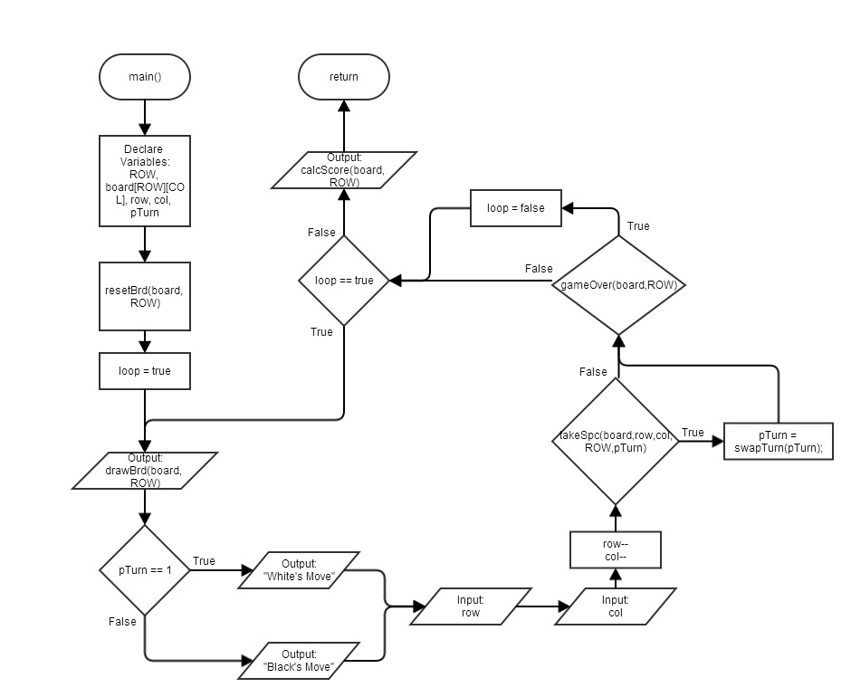

Major Variables

Type | Variable Name | Description | Location
cosnt short | COL | Constant to hold number of columns of board[][] | line 15
const short | ROW | Constant to hold number of rows of board[][] | main()/line 32
unsigned short | board[ROW][COL] | 2-D array to hold all data of the tiles on the board | main()/line 33
unsigned int | row | Holds row cords that are imputed by user | main()/line 34
unsigned int | col | Holds col cords that are imputed by user | main()/line 34
int | pTurn | Holds the current player's turn | main()/line 35
bool | loop | Used to keep track of when to jump out of loop | main()/line 38

Constructs

Type | Description | Location
If | if(gameOver(board,ROW))loop=false; | main()/line 55
If Else | if(pTurn == 1){} else{} | main()/line 41
If Else If | if(a[i][j] == 1){} else if(a[i][j] == 2){} | calcScore()/line 275
Switch | switch(a[i][j]){} | drawBrd/line 77
For | for(int i = 0; i < row; i++){} | drawBrd/line 73
While | while(!(rowInc == rQI && colInc == cQI)){} | quadFlip()/line 225
Do While | do{} while(loop); | main()/line 39
Array | board[ROW][COL] | main()/line 33
Function | void drawBrd(unsigned short a[][COL], short row){} | main()/line 64

Reference
- Pictures of Othello rules from http://www.site-constructor.com/othello/othellorules.html

Program

/*
* File: main.cpp
* Author: Jonathan D. Tarris
* Class#: 40375
* Created on February 10, 2014, 1:54 PM
* Project 2
* Othello Game v2
*/

//System Libraries
#include <cstdlib>
#include <iostream>
#include <fstream>
using namespace std;

//Global Constants
const short COL = 8;

//Function Prototypes
void drawBrd(unsigned short [][COL],short int);//Draws the current state of the board on the console
void drawLine(string);//Draws string across the entire row
void resetBrd(unsigned short [][COL],short);//Resets the board array to starting position
bool takeSpc(unsigned short [][COL],const int&,const int&,const short&,const int&);//Checks and takes space if valid move
bool flip(unsigned short [][COL],const int&,const int&,const short&,const int&);//Flips adjacent tiles if possible
bool inBound(int,int,int);//Checks if cords are in bound of array
bool quadFlip(unsigned short [][COL],const int&,const int&,const short&,const int&,int, int);//Flips subsequent adjacent tiles in-line with quadrant
int swapTurn(int);//Returns the opposite player number
bool gameOver(unsigned short [][COL],const short);//Checks to see if board is full
void calcScore(unsigned short [][COL],const short);//Calculates and displays score

//Execution Begins Here
int main(int argc, char** argv) {
//Declare Vars
const short ROW = 8;
unsigned short board[ROW][COL] = {};//Board 0 = empty, 1 = white, 2 = black
unsigned int row,col;
int pTurn = 2;//Player turn 1 = white, 2 = black
//Draw Starting Board
resetBrd(board, ROW);
bool loop = true;
do{
drawBrd(board, ROW);
if(pTurn == 1){
cout<<"White's Move"<<endl;
}else{
cout<<"Black's Move"<<endl;
}
cout<<"Row: ";
cin>>row;
cout<<"Col: ";
cin>>col;
row--;
col--;
if(takeSpc(board,row,col,ROW,pTurn))
pTurn = swapTurn(pTurn);
//if(row == 9)loop=false;
if(gameOver(board,ROW))loop=false;
}while(loop);
calcScore(board,ROW);
return 0;
}

//Draws the current state of the board on the console
void drawBrd(unsigned short a[][COL], short row){
cout<<endl;
//Draw Line Numbers
for(int i = 0; i < COL; i++){
cout<<" "<<i+1<<" ";
}
cout<<endl;
//Draw Top Line
drawLine("_________");
cout<<"_"<<endl;
//Draw all rows
for(int i = 0; i < row; i++){
//Draw First line of space
drawLine("| ");
cout<<"|"<<endl;
//Check what tile should be there Draw Second Line of space
for(int j = 0; j < COL; j++){
switch(a[i][j]){
case 0://if 0 print blank
cout<<"| ";
break;
case 1://if 1 print white
cout<<"| /::\\ ";
break;
case 2://if 2 print black
cout<<"| /##\\ ";
break;
default:
break;
}
}
cout<<"|";
//line numbers
cout<<" "<<i+1<<endl;
//Check what tile should be there Draw third Line of space
for(int j = 0; j < COL; j++){
switch(a[i][j]){
case 0://if 0 print blank
cout<<"| ";
break;
case 1://if 1 print white
cout<<"| \\::/ ";
break;
case 2://if 2 print black
cout<<"| \\##/ ";
break;
default:
break;
}
}
cout<<"|"<<endl;
drawLine("|________");
cout<<"|"<<endl;
}
}

//Draws string across the entire row
void drawLine(string s){
for(int i = 0; i < COL; i++){
cout<<s;
}
}

//Resets the board array to starting position
void resetBrd(unsigned short a[][COL],short ROW){
//reset entire array to 0
for(int i = 0; i < ROW; i++){
for(int j = 0; j < COL; j++){
a[i][j] = 0;
}
}
//set pre-determined starting positions
a[3][3] = 1;
a[3][4] = 2;
a[4][3] = 2;
a[4][4] = 1;
}

//Checks to see if space is a valid move
bool takeSpc(unsigned short a[][COL],const int &row,const int &col,const short &ROW,const int &turn){
//if inBounds
if(inBound(row,col,ROW)){
//if space is already taken or not
if(a[row][col] == 0){
//if any adjacent tiles are able to be flipped
if(flip(a, row, col, ROW, turn)){
a[row][col] = turn;
return true;
}else{
cout<<"Spot cannot flip any adjacent tiles"<<endl;
return false;
}
}else{
cout<<"Spot has already been taken"<<endl;
return false;
}
}else{
cout<<"Spot is out of bounds"<<endl;
return false;
}
}

//Flips adjacent tiles if possible
bool flip(unsigned short a[][COL],const int &row,const int &col,const short &ROW,const int &turn){
bool flipped = false;

//Check all 8 surrounding quadrants to see if any tiles can be flipped
//Logic here row/col
//Upper Left Quadrant -1/-1
if(quadFlip(a,row,col,ROW,turn,-1,-1))flipped = true;
//Upper Mid Quadrant -1/0
if(quadFlip(a,row,col,ROW,turn,-1,0))flipped = true;
//Upper Right Quadrant -1/+1
if(quadFlip(a,row,col,ROW,turn,-1,1))flipped = true;
//Right Quadrant 0/+1
if(quadFlip(a,row,col,ROW,turn,0,+1))flipped = true;
//Lower Right Quadrant +1/+1
if(quadFlip(a,row,col,ROW,turn,1,1))flipped = true;
//Lower Mid Quadrant +1/0
if(quadFlip(a,row,col,ROW,turn,1,0))flipped = true;
//Lower Left Quadrant +1/-1
if(quadFlip(a,row,col,ROW,turn,1,-1))flipped = true;
//Left Quadrant 0/-1
if(quadFlip(a,row,col,ROW,turn,0,-1))flipped = true;

//Check if any tiles were flipped and if so return true
if(flipped){
return true;
}else{
return false;
}
}

//Checks if cords are in bound of array
bool inBound(int row,int col,int ROW){
if(row < ROW && col < COL && row>=0 && col>=0){
return true;
}
return false;
}

//Flips subsequent adjacent tiles in-line with quadrant
bool quadFlip(unsigned short a[][COL],const int &row,const int &col,const short &ROW,const int &turn,int rQI,int cQI){
//Check if adjacent space is inbounds and the opposite color
if(inBound(row+rQI,col+cQI,ROW) && a[row+rQI][col+cQI] == swapTurn(turn)){
//Check to see if tile is flanked
bool loop = true;
int rowInc = rQI;
int colInc = cQI;

do{
//Increment to next adjacent space
rowInc += rQI;
colInc += cQI;

//check if incremented space is in bounds
if(inBound(row+rowInc,col+colInc,ROW)){
//Check if incremented space is empty
if(a[row+rowInc][col+colInc] != 0){
//Check to see if space is same color as current players tile
if(a[row+rowInc][col+colInc] == turn){
//Space is flanked so flip all tile in between tiles
//LOOP HERE TO CHANGE ALL TILES TO turn COLOR
while(!(rowInc == rQI && colInc == cQI)){
//reverse increment back to original space and flip tiles
rowInc -= rQI;
colInc -= cQI;
a[row+rowInc][col+colInc] = turn;
}
//return true if any tiles were filpped
return true;
}
}else{
//Reached an empty space break loop
loop = false;
}
}else{
//Went out of bounds break loop
loop = false;
}
}while(loop);
}

return false;
}

//Returns the opposite player number
int swapTurn(int turn){
if(turn == 1){
return 2;
}else{
return 1;
}
}

//Checks to see if the game is over by comparing if the board is full
bool gameOver(unsigned short a[][COL],const short ROW){
for(int i = 0; i < ROW; i++){
for(int j = 0; j < COL; j++){
if(a[i][j] == 0){
return false;
}
}
}
return true;
}

//Calculates and displays score
void calcScore(unsigned short a[][COL],const short ROW){
int wScore = 0;
int bScore = 0;
for(int i = 0; i < ROW; i++){
for(int j = 0; j < COL; j++){
if(a[i][j] == 1){
wScore++;
}else if(a[i][j] == 2){
bScore++;
}
}
}
cout<<endl;
cout<<"Black's Score: "<<bScore<<endl;
cout<<"White's Score: "<<wScore<<endl;
//Create file Stream
ofstream fout;
fout.open("score.dat",ios::app);
if(wScore > bScore){
cout<<"White is the Winner!!!"<<endl;
//Append Score to High Score list
fout<<wScore<<"\n";
}else if(bScore > wScore){
cout<<"Black is the Winner!!!"<<endl;
//Append Score to High Score list
fout<<bScore<<"\n";
}else{
cout<<"Draw Game"<<endl;
}
fout.close();
}

